**Heuser — Mapping**

<3 maps, 1 figure>

**Mapping the Emotions of London in Fiction, 1700–1900: A Crowdsourcing Experiment**

Heuser, R., Algee-Hewitt, M., Tran, V., Lockhart, A. and Steiner, E.

Digital literary geography (DLG) has already made possible important discoveries into the geographic patterns of large-scale corpora of fiction. For instance, Matthew Wilkens has shown that the rise of literary regionalism, argued to have taken place in response to the Civil War, does not actually manifest in a large corpus of American fiction published in the surrounding decades. For Wilkens, this methodology—counting how often place-names appear in texts—can effectively operationalize a text’s ‘geographic investment’ with particular places (Wilkens, 2013, 804).

We find the concept of geographic investment as foundational to DLG as patterns, according to Barbara Piatti, were to the emergence of literary geography. Early maps, such as William Sharp’s 1904 map of the chief localities of Walter Scott’s novels, ‘succeeded to visualise a couple of important aspects’ of the emerging field, namely ‘the distribution of fictional settings (“gravity centers” vs. “unwritten regions”)’ (Piatti et al., 2009, 181). At the same time, we believe that a key challenge for DLG will be to demonstrate its ability to further qualify and differentiate what is meant by ‘investment’. It seems important to understand, for instance, that the rise of mentions of India in 19th-century British novels is predominantly due to their frequent appearances in off-hand explanations of the origin of someone’s wealth or some imported good (Jockers et al., 2012). Similarly, it seems essential for DLG to develop methods by which it can articulate a range of ways in which place-names operate in fiction, visualizing distinct modes of attention both historically and geographically.

This paper presents a visualization and interpretation of the geographic investment with real London places in 18th- and 19th-century English-language fiction.1 It also attempts to visualize two distinct qualifications of this investment. We have applied emerging techniques in crowdsourcing to derive from a consensus of readers two pieces of information regarding the way in which a place-name was invoked in a fictional passage. Was it the setting of the passage, or simply mentioned? Was the emotion of fear, or happiness, associated with the place in the passage?

In addition to narrative setting, we take emotion to play an important role in a project such as this, balanced between questions of literary form and social geography. In the affect-theoretical work of Sianne Ngai, emotions act ‘as a mediation between the aesthetic and the political in a nontrivial way’ (Ngai, 2004, 3). In their polarity between positive engagement and negative withdrawal, happiness and fear can be felt in the tone in which places are invoked in fiction. Mapping these tonal associations reveals one emotional spectrum along which fiction affectively mediated its relationship to London throughout two centuries of urbanization, industrialization and the rise of urban poverty, literacy, the bourgeoisie, and the novel.

**Experiment 1: Geographic Investment**

*Method*

We developed a list of locations in London to search for in a corpus of texts, through a combination of computational toponym discovery (using the Named Entity Recognizer of the Stanford NLP toolkit) and research into historical gazetteers and maps of London. From this list, 161 places were chosen for all experiments presented in this paper.2 We read random passages mentioning each of the place-names, identifying ten passages per half-century in which the place-name actually referred to the London place we assumed it to. These passage annotations also supplied a statistic on the likelihood of a particular name to refer to a place. For instance, in fiction from 1750 to 1800, ‘Bond Street’ seems to refer to the street about 100% of the time, while the ‘Tower’ to the Tower of London about 90% of the time. These likelihoods are multiplied against the total count of each place-name across all fiction from a given half-century, and visualized in the following map.

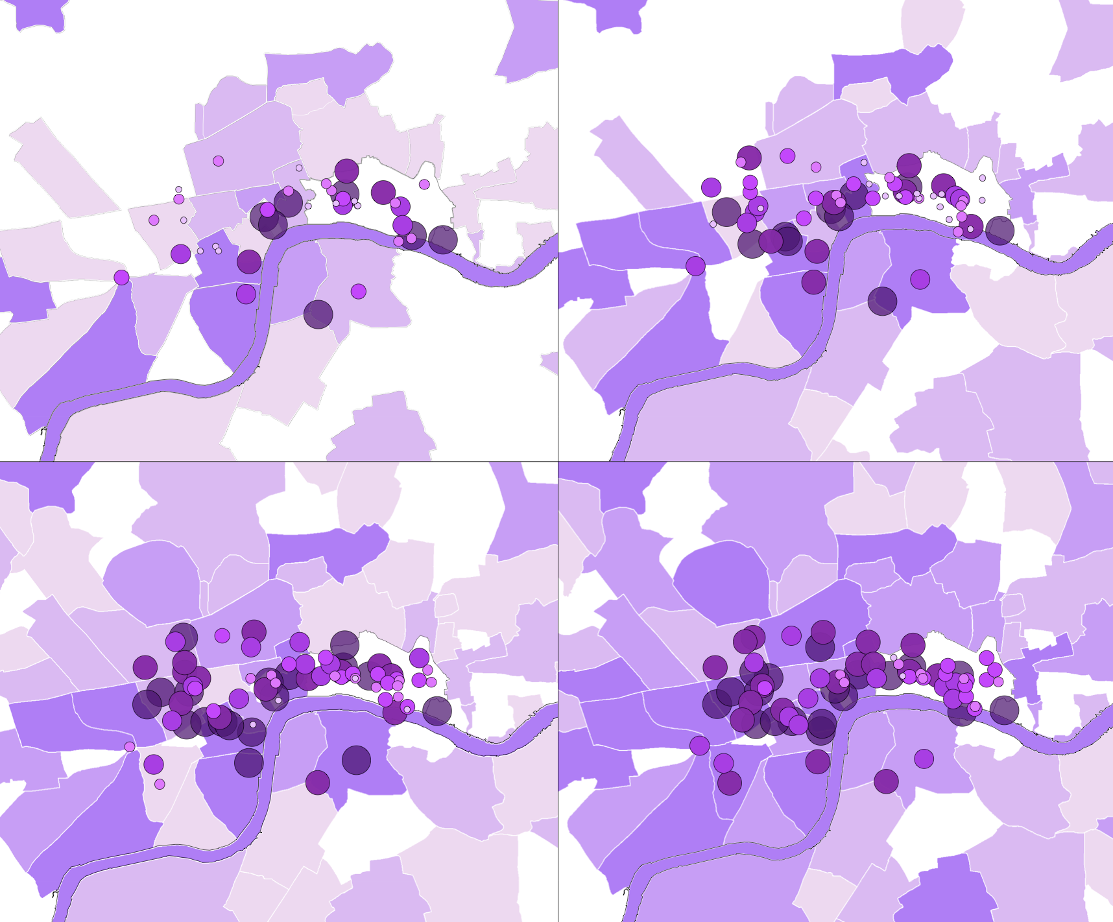

Map 1. Fiction’s geographic investment with London, 1700–1900. The four tiles, read left to right, represent a fictional geography of the works published in the four half-centuries of 1700–1900, respectively. Circles represent discrete places in our corpus—streets, buildings, squares—while polygons represent wider spaces such as districts or neighborhoods. The depth of color, and the size of circle, reflect the same data: the overall likelihood for fiction of the period to mention that place.

*Interpretation*

We find a ‘gravity center’ of fictional attention to London spaces, located in the City and West End, that is surprisingly stable across two centuries of dramatic urban expansion. Comparing the distribution of fictional attention to population by London borough across the 19th century, we find that the most frequently mentioned boroughs—the City, Westminster, and Camden—are those that least correlate with population change.3 All three decline in relative population while remaining stable in their dominance of relative fictional attention. The responsiveness of literary representation to social change has always remained a contentious question for literary theory: here, we find not responsiveness, but a kind of ‘stuckness’, a tendency to continually reinvest London places already imbued with centuries of public meaning.

**Experiment 2: Crowdsourcing Emotional Investment**

*Method*

We used the Amazon crowdsourcing platform, Mechanical Turk, to derive a consensus of readers’ annotations to overlay onto the foregoing map. For each place in each half-century, we gave ten passages to twenty readers each. All twenty annotated whether the highlighted place-name acted as the setting of the passage. Ten annotated whether the emotion of fear was associated or experienced in the place; ten for happiness.4 Averaging these annotations per place per period produced the following two maps.

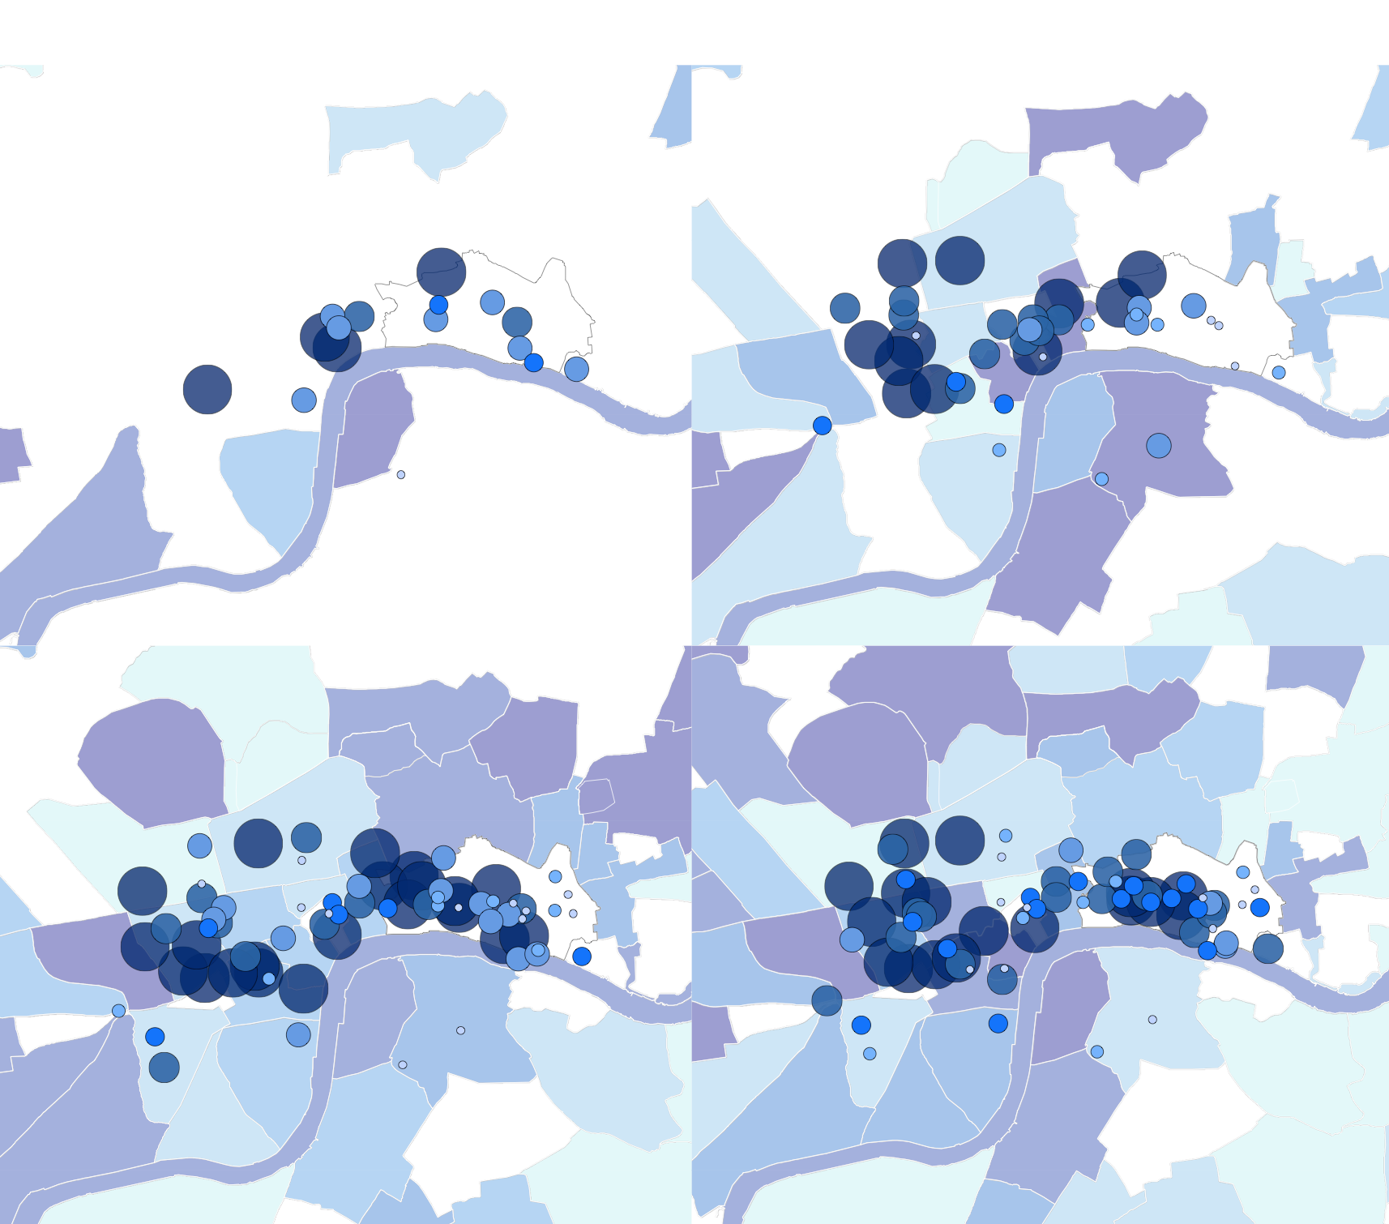

Map 2. Likelihood of narrative setting.The four tiles, read left to right, represent a fictional geography of the works published in the four half-centuries of 1700–1900, respectively. Circles represent discrete places in our corpus—streets, buildings, squares—while polygons represent wider spaces such as districts or neighborhoods. The depth of color, and the size of circle, reflect the same data: the overall likelihood for fiction of the period to act as the setting of a passage.

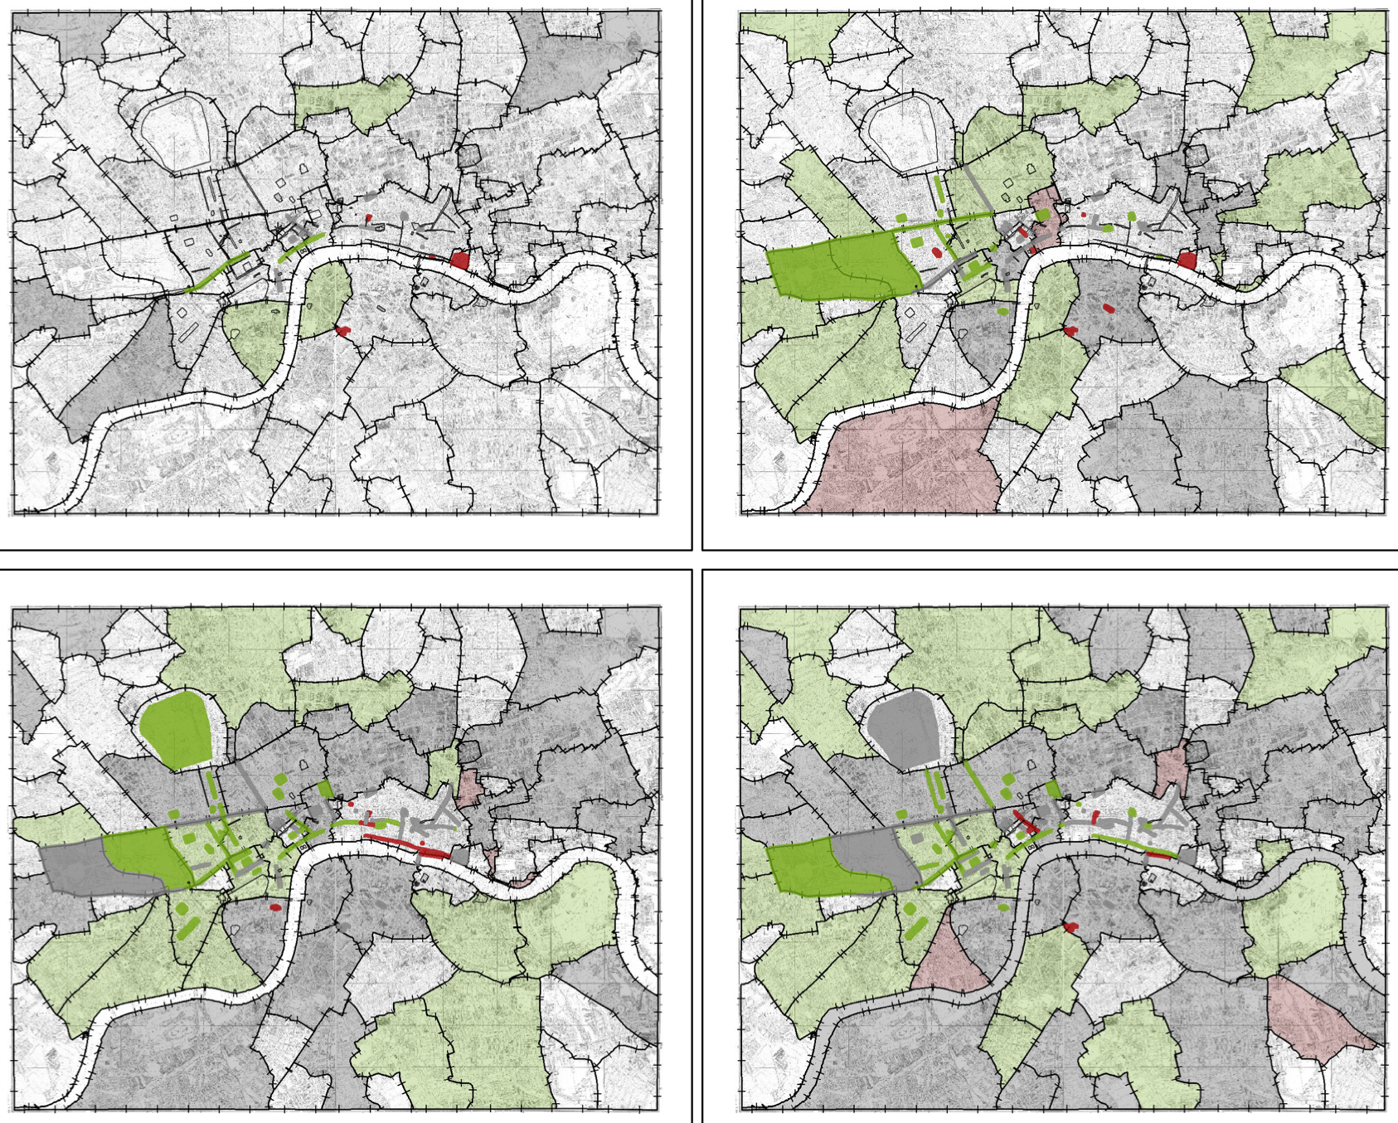

Map 3. Emotional polarity in fiction. The four tiles, read left to right, represent a fictional geography of the works published in the four half-centuries of 1700–1900, respectively. All places are now represented as geographic polygons. The color scale, from green to red, represents the likelihood of a place to be associated with happiness, subtracted by its likelihood to be associated with fear, in the fiction of that period. Gray areas are not likely to be associated with either (neutral).

*Interpretation*

We observe a spatial bifurcation in fiction’s emotional representations of London places: locations in the City, South, and East are more likely to be associated with fear than locations in the West and North. We test this observation by modeling the spatial patterns in the likelihoods of narrative setting, fear, and happiness, with the spatial patterns of four social-geographic data: the location of the place, whether in the City, or South, East, North, or West of it; the function of the place, whether Prison, Church, Square, etc.; the age of the place, whether deriving from the Roman and medieval eras or from the Tudor era onward; and finally, the social class of the place, as measured using remote sensing techniques applied to its immediate vicinity on Booth’s 1889 map of income classes in London. These four independent data are treated as factors in an odds ratio in order to measure the extent to which they statistically affect the likelihood for setting, fear, and happiness. The significant odds ratios (>1.4) are visualized in the following network.

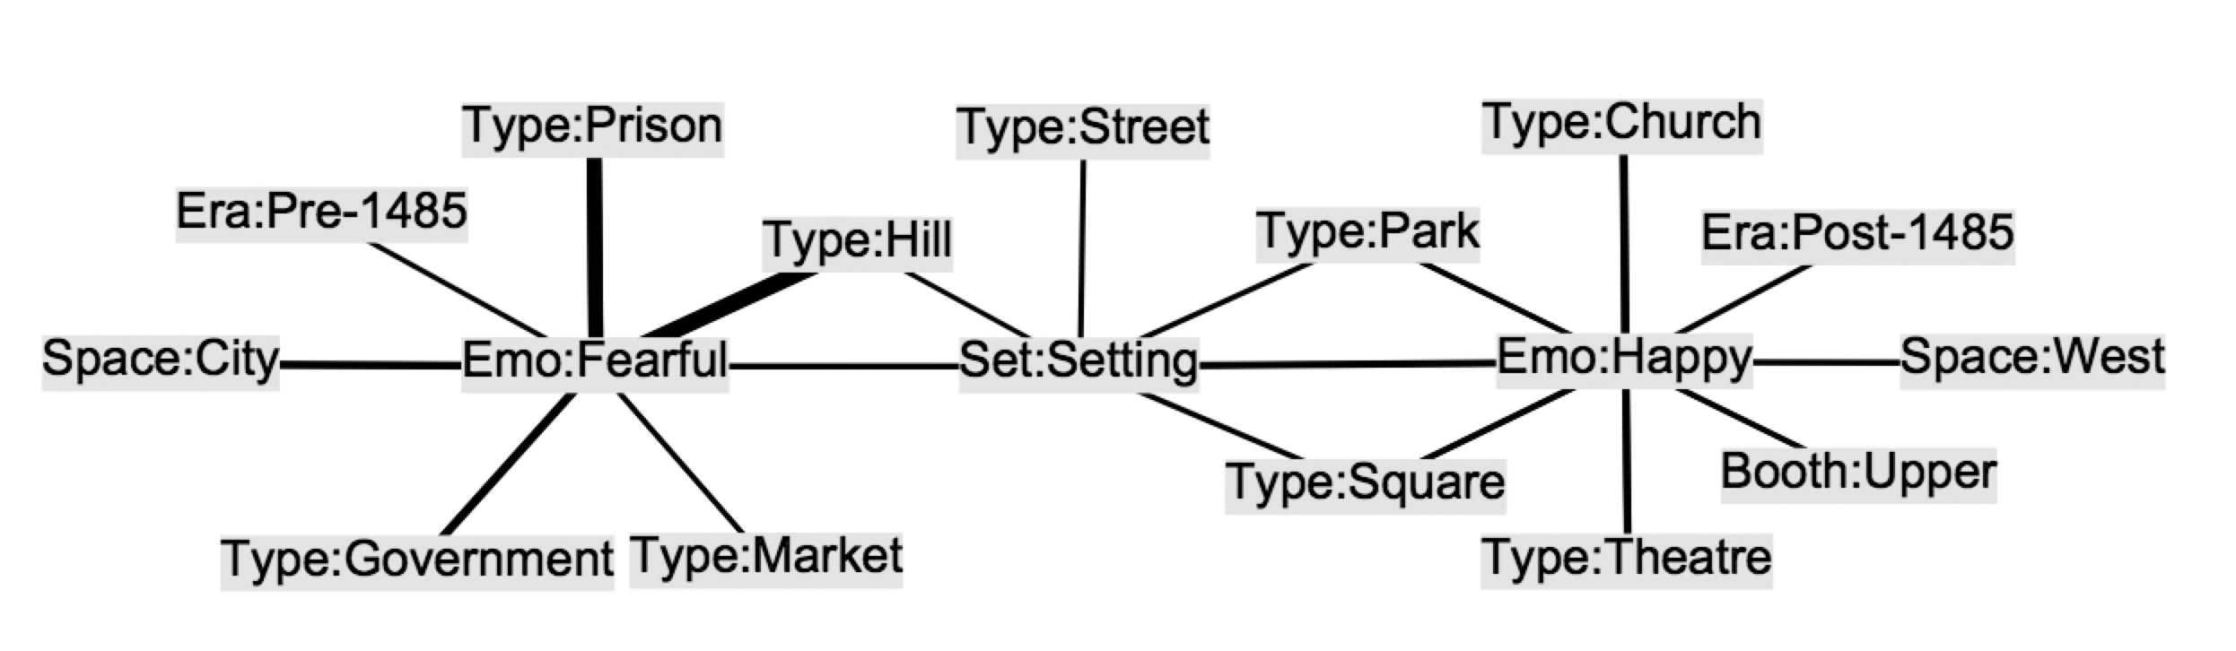

Figure 1. Factors influencing setting, fear, and happiness.

Emotional representations of fear and happiness articulate two distinct geographies of London. Prisons, hills (which have prisons associated with them), pre-modern buildings, and places in the City are more likely be associated with fear. Parks, churches, squares, theatres, modern buildings, places in the West, and places around which Booth had indicated upper-class residents lived are more likely to be associated with happiness. Interestingly, the only factor making both emotions more likely is a factor of narrative form: whether the passage was embodied in the place through its narrative setting. We interpret these results further and argue for the relevance of DLG in articulating nuanced geographies of literary history.

**Notes**

1. Our corpus derives from the Literary Lab’s fictional corpus, and includes 5,000 works of English-language fiction published between 1700 and 1900.

2. Places were chosen if appearing with a minimum frequency of 0.2% of the total occurrences of London places in any half-century of fiction from 1700 to 1900. In addition, the name of each London district identified on Booth’s 1889 map of London was included to ensure sufficient spatial representation of parts of the South and East of London.

3. Population data was retrieved from UK census data on historical population in London by borough: data.london.gov.uk/datastore/package/historic-census-population. The ‘West End’ is spatially represented in the data by the contemporary borough of Westminster.

4. Our process of quality control was as follows. We applied statistical techniques to determine whether readers behaved, on average, more like other readers than would random chance. In borderline cases, manual inspection was made to determine whether the data was unlikely to have been entered sincerely, in which case we excluded it from our analysis.

**References**

**Jockers, M. L., with Allen, B., Blevins, C. and Heuser, R.** (2012). A Geography

of Nineteenth-Century English and American Literature. *Social Science History Association, 37th Annual Meeting*, Vancouver, British Columbia, 2 November 2012.

**Ngai, S.** (2004). *Ugly Feelings*. Harvard University Press, Cambridge.

**Piatti, B., Bär, H. R., Reuschel, A.-K., Hurni, L. and Cartwright, W.** (2009). Mapping Literature: Towards a Geography of Fiction. In Cartwright, W., Gartner, G. F., and Lehn, A. (eds), *Cartography and Art*. Berlin: Springer, pp. 179–94.

**Wilkens, M.** (2013). The Geographic Imagination of Civil War–Era American Fiction. *American Literary History,* **25**(4): 803–40.

**Williams, R.** (1977). *Marxism and Literature*. Oxford University Press, Oxford.